The Circulatory System
The circulatory system consists of the

Its function is to transport various substances around the body. These are

Blood
The human body has about _____ litres of blood. Human blood is made of four components; plasma, red blood cells, white blood cells and platelets.

Plasma
Plasma is the main component of blood, consisting mainly of _______ . It is pale ________ in colour. Plasma carries ___________ _______ , ___________ and _______ . Suspended in the plasma are the ________ and ____ blood cells and __________ .

Red Blood Cells
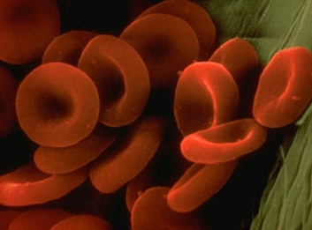
Red blood cells carry _____ throughout the body. Oxygen combines with an _____ containing chemical called _________________ in the blood cells. Red blood cells are _______ shaped and do not have a ___________ .

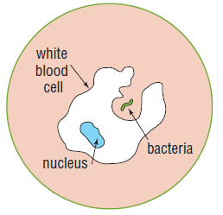
White Blood Cells
White blood cells are _________ and _____ ___________ than red blood cells. They have ___ _________ _______ , but possess a __________ . White blood cells are mostly involved in __________ ____________ . They protect the body from disease by ‘eating’ _________ ___________ and __________ in the blood.

Platelets
Platelets are tiny cells with no _________ . They are involved in the ____________ ___ _________ . Platelets form sticky _______ that plug up damaged _________ _____________ .

Blood Vessels
Blood travels along tubes called blood vessels. There are three types of blood vessels;

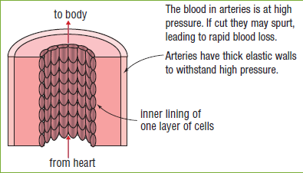
Arteries
Arteries carry ______________ blood away from the heart to ________ and ________ . The walls of arteries are ________ , ___________ and _________ . Blood is pumped through arteries under pressure. Smaller arteries are called arterioles.

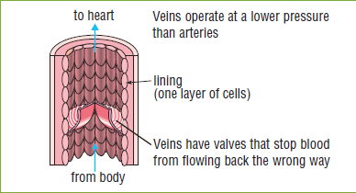
Veins
Veins return ________________ blood from the body to the heart. They have thinner, more __________ walls than arteries. Veins have ________ to stop the blood flowing ______________ . Smaller veins are called venules.

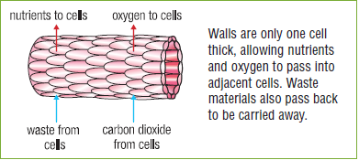
Capillaries
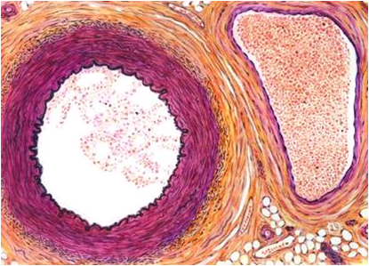
Capillaries are the smallest blood vessels and they are only one cell thick. The allow transport of ________ and ________ into body cells and transport ________ out of body cells.

